

Network Security and Forensics

Lab Session 6

Submitted To:- Submitted By:-

Dr. Lokesh Chauhan Sir Saloni Rangari

M.Tech. AIDS

**Assignment 1: Write a program to demonstrate Row Transposition Cipher. Take Plaintext input form File and Also Ciphertext store in File.**

import math  
  
def encrypt_row_transposition(plain_text, key):  
 # Convert the key to a list of numbers for reordering the columns  
 key_length = len(key)  
 sorted_key = sorted(list(key))  
 col_order = [sorted_key.index(k) for k in key]  
  
 # Calculate the number of rows needed for the grid  
 rows = math.ceil(len(plain_text) / key_length)  
  
 # Fill the grid with the plaintext (padding with spaces if necessary)  
 grid = ['' for _ in range(rows)]  
 index = 0  
 for r in range(rows):  
 for c in range(key_length):  
 if index < len(plain_text):  
 grid[r] += plain_text[index]  
 index += 1  
 else:  
 grid[r] += ' ' # Padding  
  
 # Reorder the columns according to the column order derived from the key  
 encrypted_text = ''  
 for c in col_order:  
 for r in range(rows):  
 encrypted_text += grid[r][c]  
  
 return encrypted_text.replace(' ', '') # Remove padding spaces in final ciphertext  
  
def decrypt_row_transposition(cipher_text, key):  
 # Calculate the number of rows  
 key_length = len(key)  
 rows = math.ceil(len(cipher_text) / key_length)  
  
 # Sort the key to determine column positions  
 sorted_key = sorted(list(key))  
 col_order = [sorted_key.index(k) for k in key]  
  
 # Create a grid for the decrypted message  
 grid = ['' for _ in range(rows)]  
  
 # Fill the columns in the order based on the key  
 index = 0  
 for c in col_order:  
 for r in range(rows):  
 if index < len(cipher_text):  
 grid[r] += cipher_text[index]  
 index += 1  
  
 # Read the grid row by row to reconstruct the plaintext  
 decrypted_text = ''.join(grid)  
 return decrypted_text.strip() # Strip off any trailing spaces  
  
def read_file(file_path):  
 with open(file_path, 'r') as file:  
 return file.read().strip()  
  
def write_file(file_path, content):  
 with open(file_path, 'w') as file:  
 file.write(content)  
  
def main():  
 # File paths  
 input_file = 'RTC_Plain_Text.txt' # Input file containing plaintext  
 output_file = 'RTC_Cipher_Text.txt' # Output file to store ciphertext  
  
 # Read plaintext from the input file  
 plaintext = read_file(input_file)  
 print(f"Plaintext: {plaintext}")  
  
 key = input("\nEnter the key: ")  
  
  
 # Encrypt the plaintext using Row Transposition Cipher  
 ciphertext = encrypt_row_transposition(plaintext, key)  
 print(f"\nCiphertext: {ciphertext}")  
  
 # Write the encrypted ciphertext to the output file  
 write_file(output_file, ciphertext)  
  
 # Optional: Decrypt to verify  
 decrypted_text = decrypt_row_transposition(ciphertext, key)  
 print(f"Decrypted Text: {decrypted_text}")  
  
if __name__ == "__main__":  
 main()

**Output:**

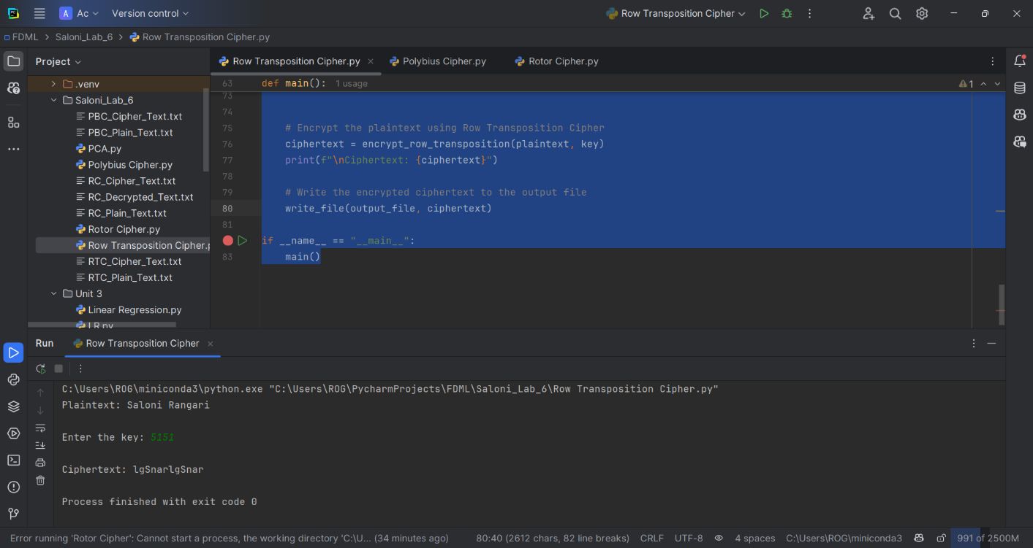

**Assignment 2: Write a program to demonstrate Polybius Cipher  
Take Plaintext input form File and Also Ciphertext store in File.**

def create_polybius_square():  
 square = [['A','B','C','D','E'],  
 ['F','G','H','I','K'],  
 ['L','M','N','O','P'],  
 ['Q','R','S','T','U'],  
 ['V','W','X','Y','Z']]  
  
 return square  
  
  
def polybius_encrypt(plain_text):  
 square = create_polybius_square()  
 encrypted_text = ''  
  
 plain_text = plain_text.upper().replace('J','I') # Convert to uppercase and replace J with I  
  
 for char in plain_text:  
 if char.isalpha(): # Only encrypt alphabetic characters  
 for row in range(5):  
 if char in square[row]:  
 col = square[row].index(char)  
 encrypted_text += str(row + 1) + str(col + 1) # Append row+col to the ciphertext  
 break  
 else:  
 encrypted_text += char # Non-alphabetic characters remain unchanged  
  
 return encrypted_text  
  
  
def polybius_decrypt(cipher_text):  
 square = create_polybius_square()  
 decrypted_text = ''  
 i = 0  
  
 while i < len(cipher_text):  
 if cipher_text[i].isdigit() and cipher_text[i + 1].isdigit(): # Ensure it's a pair of digits  
 row = int(cipher_text[i]) - 1  
 col = int(cipher_text[i + 1]) - 1  
 decrypted_text += square[row][col]  
 i += 2 # Move to the next pair  
 else:  
 decrypted_text += cipher_text[i] # Non-numeric characters remain unchanged  
 i += 1  
  
 return decrypted_text  
  
  
def read_file(file_path):  
 with open(file_path,'r') as file:  
 return file.read().strip()  
  
  
def write_file(file_path,content):  
 with open(file_path,'w') as file:  
 file.write(content)  
  
  
def main():  
 # File paths  
 input_file = 'PBC_Plain_Text.txt' # Input file containing plaintext  
 output_file = 'PBC_Cipher_Text.txt' # Output file to store ciphertext  
  
 # Read plaintext from the input file  
 plaintext = read_file(input_file)  
 print(f"\nPlaintext: {plaintext}")  
  
 # Encrypt the plaintext using Polybius Cipher  
 ciphertext = polybius_encrypt(plaintext)  
 print(f"\nCiphertext: {ciphertext}")  
  
 # Write the encrypted ciphertext to the output file  
 write_file(output_file,ciphertext)  
  
 # Optional: Decrypt to verify  
 decrypted_text = polybius_decrypt(ciphertext)  
 print(f"\nDecrypted Text: {decrypted_text}")  
  
  
if __name__ == "__main__":  
 main()

**Output:** 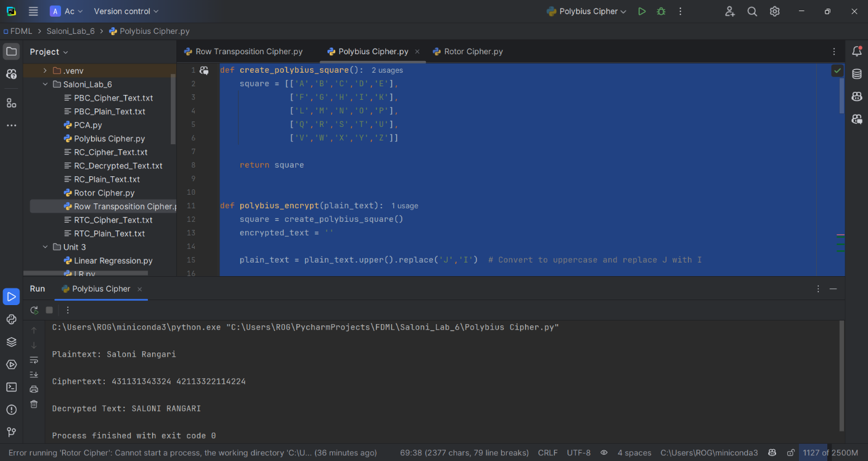

**Assignment 3:  Write a program to demonstrate the Rotor Cipher (as discussed in the classroom).**

**Take the following inputs:**

* **Plaintext**
* **No. of Rotor**
* **Angle of Each Rotor**

import string  
  
  
def get_shift_from_angle(angle):  
 degrees_per_shift = 360 / 26  
 return int(angle // degrees_per_shift) % 26 # Return the shift value (mod 26)  
  
  
def apply_rotor_cipher(plain_text,rotors,angles):  
 alphabet = string.ascii_uppercase  
 encrypted_text = ''  
 plain_text = plain_text.upper() # Convert to uppercase for simplicity  
 rotor_positions = [0] * rotors # Track the rotor positions  
  
 for i,char in enumerate(plain_text):  
 if char in alphabet: # Only process alphabetic characters  
 shift = 0  
 # Calculate the total shift based on rotor positions  
 for j in range(rotors):  
 rotor_shift = get_shift_from_angle(angles[j])  
 shift += (rotor_positions[j] + rotor_shift) % 26  
  
 # Find the encrypted character by applying the total shift  
 current_index = alphabet.index(char)  
 shifted_index = (current_index + shift) % 26 # Shift index mod 26  
 encrypted_text += alphabet[shifted_index]  
  
 # Rotate each rotor after processing a character  
 for j in range(rotors):  
 rotor_positions[j] = (rotor_positions[j] + 1) % 26 # Rotor rotates after each character  
 else:  
 encrypted_text += char # Non-alphabetic characters remain unchanged  
  
 return encrypted_text  
  
  
def read_file(file_path):  
 with open(file_path,'r') as file:  
 return file.read().strip()  
  
  
def write_file(file_path,content):  
 with open(file_path,'w') as file:  
 file.write(content)  
  
  
def main():  
 # Input file containing plaintext  
 input_file = 'RC_Plain_Text.txt'  
 # Output file to store ciphertext  
 output_file = 'RC_Cipher_Text.txt'  
  
 # Read plaintext from the input file  
 plaintext = read_file(input_file)  
 print(f"Plaintext: {plaintext}")  
  
 # Get user inputs  
 rotors = int(input("Enter the number of rotors: "))  
 angles = []  
 for i in range(rotors):  
 angle = float(input(f"Enter the angle for Rotor {i + 1} (in degrees): "))  
 if angle <= 0:  
 print("Angle must be positive!")  
 return  
 angles.append(angle)  
  
 # Encrypt the plaintext using Rotor Cipher  
 ciphertext = apply_rotor_cipher(plaintext,rotors,angles)  
 print(f"Ciphertext: {ciphertext}")  
  
 # Write the encrypted ciphertext to the output file  
 write_file(output_file,ciphertext)  
  
 # Optional: Decrypt to verify  
 decrypted_text = apply_rotor_cipher(ciphertext,rotors,angles)  
 print(f"Decrypted Text: {decrypted_text}")  
  
if __name__ == "__main__":  
 main()

**Output:**

